### **To check positive or negative number**

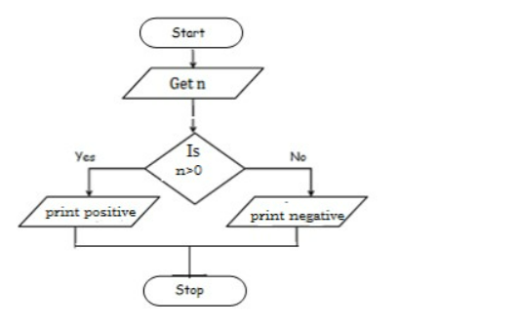

GET the value of n THEN

IF n is less greater than 0

DISPLAY “positive”

ELSE

DISPLAY “negative”

END

### **To check odd or even number**

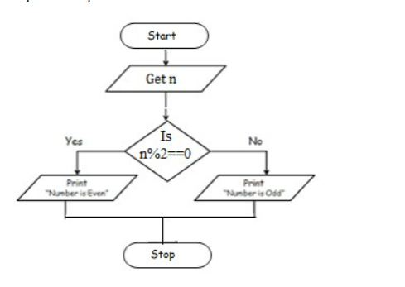

GET the value of n THEN

IF modulo 2 is equal to 0

DISPLAY “Number is Even”

ELSE

DISPLAY “Number is Odd”

END

### 

### **To check greatest of three numbers**

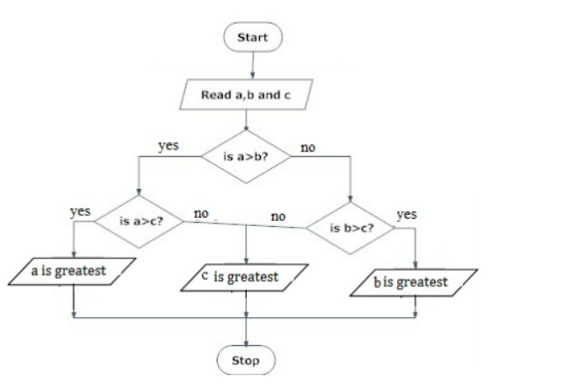

READ the value of a,b,c THEN

IF a is greater than B

IF a is greater than C

DISPLAY “a is greatest”

ELSE

DISPLAY “c is greatest”

ELSE IF a is not greater than b

IF b is greater than c

DISPLAY “b is greatest”

ELSE

DISPLAY “c is greatest”

END